

# Shaheed Zulfikar Ali Bhutto Institute of Science & Technology

**COMPUTER SCIENCE DEPARTMENT**

**Applied Physics (Lab)**

**Project Proposal**[Arduino: LED Sequential Control]

Submitted To: Syed Mohsin Ali Shah

Students Name: Farooq Ahmed Khan, Azhar Kamal

Reg. Numbers: 2012302, 2012299

# Shaheed Zulfikar Ali Bhutto Institute of Science & Technology

**COMPUTER SCIENCE DEPARTMENT**

1. Summary:   
   This is a LED sequential control circuit powered by Arduino. To build this, we will use a Breadboard, 12 resistors, 12 LEDs, Arduino Uno and code in C++. The project when ready, will display the LEDs in a sequential pattern in seven different effects.
2. Introduction:

We will build a circuit powered by Arduino Uno. Which will display the LEDs in a sequential pattern in seven different effects, and it will create a decorative lighting effect. The effects will include displaying LEDs in different orders by controlling its sequence through Arduino Uno with C++ code. This circuit can be used in different big projects and in daily life with different purposes.

1. Goals/Objectives:
   * To widen our knowledge of circuit and how do they work
   * To use this basic project in big scale projects.
   * To make custom modifications in this project for the next project to enhance its capabilities.
   * To increase our thinking ability to produce new invention that can make people life easier.
   * To expand team work projects as preparation for work lifestyle in future.
   * To enhance critical thinking.
   * We can save the lives of many people by using these LEDs in traffic signals.
   * We can save the lives of employs working in different areas like factories, petrol filling stations and banks etc. Where there is high risk of fire explosion when there is an emergency, the LEDs will turn on and off in different pattern and it create alert that there is a fire.
   * We can use these LEDs in tall building near Airports which can show that there is a high building.
2. **Evaluation:**
   * + First of all, we put together all the components to be used to make the circuit.
     + To build led chaser we need a breadboard to create a connection between a component.
     + We need 12 resistors of 220 Ohms each and 12 LEDs of the same colour or a different colour.
     + Attach all LEDs to the breadboard in parallel form.
     + After the LED is attached, now connect the resistor to the positive pin of all LEDs.
     + Now connect the end of the resistors to pin 2, 3, 4, 5, 6, 7, 8, 9, 10, 11,12, 13 of the Arduino using a jumper wire.
     + Connect the negative pin of all LEDs to the GND pin of Arduino using a jumper wire.
     + Now the circuit is ready to upload the code through Arduino Uno.
     + Now, we will upload the code in Arduino Uno board and then we will Run the circuit.
     + The circuit will start its operation of displaying LEDs in sequences and different effects, we will compare the outcome/output with the code that if it runs accordingly. This project will reduce the traffic accidents and make the flow of traffic in a smooth way.
3. 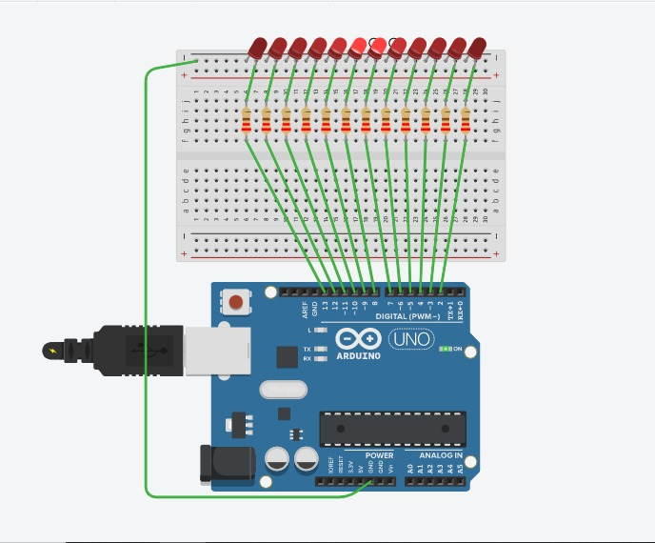**Circuit Diagram:**
4. Hardware Components:
   * + 1 × Arduino board.
     + 1 × Breadboard.
     + 12 × 5mm LEDs
     + 12 × Resistor (220Ω).
     + 12 × Jumper wires (M).
     + USB Cable

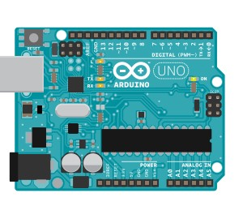Arduino Uno:

The Arduino Uno is an open-source microcontroller board based on the Microchip ATmega328P microcontroller and developed by Arduino. The board is equipped with sets of digital and analog input/output (I/O) pins that may be interfaced to various expansion boards (shields) and other circuits. The board has 14 digital I/O pins (six capable of PWM output), 6 analog I/O pins, and is programmable with the Arduino IDE (Integrated Development Environment), via a type B USB cable. It can be powered by the USB cable or by an external 9-volt battery, though it accepts voltages between 7 and 20 volts. It is similar to the Arduino Nano and Leonardo. The word "uno" means "one" in Italian and was chosen to mark the initial release of Arduino Software. The Uno board is the first in a series of USB-based Arduino boards it and version 1.0 of the Arduino IDE were the reference versions of Arduino, which have now evolved to newer releases. The ATmega328 on the board comes preprogrammed with a bootloader that allows uploading new code to it without the use of an external hardware programmer.

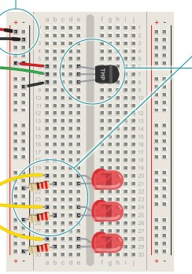 **Bread Board:**

A breadboard, or protoboard, is a construction base for prototyping of electronics. Originally the word referred to a literal bread board, a polished piece of wood used when slicing bread. In the 1970s the solderless breadboard (a.k.a. plugboard, a terminal array board) became available and nowadays the term "breadboard" is commonly used to refer to these. Because the solderless breadboard does not require soldering, it is reusable. This makes it easy to use for creating temporary prototypes and experimenting with circuit design. For this reason, solderless breadboards are also popular with students and in technological education. Older breadboard types did not have this property. A stripboard (Veroboard) and similar prototyping printed circuit boards, which are used to build semi-permanent soldered prototypes or one-offs, cannot easily be reused. A variety of electronic systems may be prototyped by using breadboards, from small analog and digital circuits to complete central processing units (CPUs). Compared to more permanent circuit connection methods, modern breadboards have high parasitic capacitance, relatively high resistance, and less reliable connections, which are subject to jostle and physical degradation. Signaling is limited to about 10 MHz, and not everything works properly even well below that frequency.

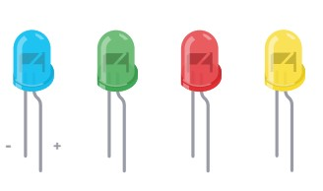LEDs:  
A light-emitting diode (LED) is a semiconductor light source that emits light when current flows through it. Electrons in the semiconductor recombine with electron holes, releasing energy in the form of photons. The color of the light (corresponding to the energy of the photons) is determined by the energy required for electrons to cross the band gap of the semiconductor. White light is obtained by using multiple semiconductors or a layer of light-emitting phosphor on the semiconductor device.

Appearing as practical electronic components in 1962, the earliest LEDs emitted low-intensity infrared (IR) light. Infrared LEDs are used in remote-control circuits, such as those used with a wide variety of consumer electronics. The first visible-light LEDs were of low intensity and limited to red. Modern LEDs are available in visible, ultraviolet (UV), and infrared wavelengths, with high light output.

Early LEDs were often used as indicator lamps, replacing small incandescent bulbs, and in seven-segment displays. Recent developments have produced high-output white light LEDs suitable for room and outdoor area lighting. LEDs have led to new displays and sensors, while their high switching rates are useful in advanced communications technology.

LEDs have many advantages over incandescent light sources, including lower energy consumption, longer lifetime, improved physical robustness, smaller size, and faster switching. LEDs are used in applications as diverse as aviation lighting, fairy lights, automotive headlamps, advertising, general lighting, traffic signals, camera flashes, lighted wallpaper, horticultural grow lights, and medical devices.

Unlike a laser, the light emitted from an LED is neither spectrally coherent nor even highly monochromatic. However, its spectrum is sufficiently narrow that it appears to the human eye as a pure (saturated) color. Also, unlike most lasers, its radiation is not spatially coherent, so it cannot approach the very high brightness characteristic of lasers.

Resistors:

A resistor is a passive two-terminal electrical component that implements electrical resistance as a circuit element. In electronic circuits, resistors are used to reduce current flow, adjust signal levels, to divide voltages, bias active elements, and terminate transmission lines, among 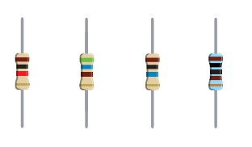other uses. High-power resistors that can dissipate many watts of electrical power as heat, may be used as part of motor controls, in power distribution systems, or as test loads for generators. Fixed resistors have resistances that only change slightly with temperature, time or operating voltage. Variable resistors can be used to adjust circuit elements (such as a volume control or a lamp dimmer), or as sensing devices for heat, light, humidity, force, or chemical activity. Resistors are common elements of electrical networks and electronic circuits and are ubiquitous in electronic equipment. Practical resistors as discrete components can be composed of various compounds and forms. Resistors are also implemented within integrated circuits.

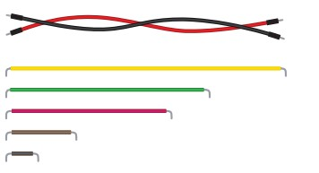Jumper wires:

A jump wire (also known as jumper, jumper wire, jumper cable, DuPont wire or cable) is an electrical wire, or group of them in a cable, with a connector or pin at each end (or sometimes without them – simply "tinned"), which is normally used to interconnect the components of a breadboard or other prototype or test circuit, internally or with other equipment or components, without soldering.

Individual jump wires are fitted by inserting their "end connectors" into the slots provided in a breadboard, the header connector of a circuit board, or a piece of test equipment.

Types:

There are different types of jumper wires. Some have the same type of electrical connector at both ends, while others have different connectors. Some common connectors are:

• Solid tips – are used to connect on/with a breadboard or female header connector. The arrangement of the elements and ease of insertion on a breadboard allows increasing the mounting density of both components and jump wires without fear of short-circuits. The jump wires vary in size and color to distinguish the different working signals.

• Crocodile clips – are used, among other applications, to temporarily bridge sensors, buttons and other elements of prototypes with components or equipment that have arbitrary connectors, wires, screw terminals, etc.

• Banana connectors – are commonly used on test equipment for DC and low-frequency AC signals.

• Registered jack (RJnn) – are commonly used in telephone (RJ11) and computer networking (RJ45).

• RCA connectors – are often used for audio, low-resolution composite video signals, or other low-frequency applications requiring a shielded cable.

• RF connectors – are used to carry radio frequency signals between circuits, test equipment, and antennas.

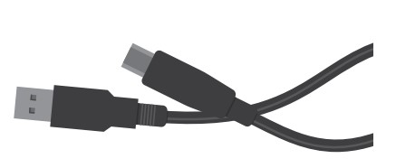• RF jumper cables - Jumper cable is a smaller and more bendable corrugated cable which is used to connect antennas and other components to network cabling. Jumpers are also used in base stations to connect antennas to radio units. Usually, the most bendable jumper cable diameter is 1/2".

USB Cable:

USB cable type A/B. Use it to connect Arduino Uno, Arduino Mega 2560, Arduino 101 or any board with the USB female A port of your computer. Cable length is approximately 1m. Cable color and shape may vary slightly from image as our stock rotates.

1. Practical Applications:

* This project/circuit can be used in Security Systems like alarms, fire alarms, emergency alarms. So, whenever an emergency emerges, the alarm will go ON and the LED(s) with that will display in a sequence and then administration of that System and people after seeing the LED(s) displaying in specific sequence will know that there is an emergency.
* This circuit can be used in law enforcement vehicles, ambulances and firefighter’ vehicles. Which will display LED(s) in specific sequence so the traffic will know that there is an emergency and they will leave a way for the vehicles, hence it will enhance the emergency response far better.
* They can be used in other projects to display LED(s) at a specific time or actions so that the team working on project/application will know the reason of LED displaying and then they will take the actions needed.
* The circuit with some enhancements is being used in traffic lights too.
* We can use these lights in Petrol filling stations, when there is a fire the LEDs blink in different pattern and show that there is an emergency. It can save the precious lives.